Role Creation for ACL Operations
Project Development Phase | 2 of 7
Project | Script-Controlled ACL - Restrict Record Access Based on Field Value
Date / Team ID | 1 October 2026 | Team ID: [enter team ID]

Purpose
Create four small roles so the project can test each record operation independently. The screenshots show bb1, bb2, bb3, and bb4 assigned to EEE User. They support bb1 for the role check, bb2 for Create, bb3 in a generic ACL conditions screen, and bb4 for Delete. The dedicated Write ACL screenshot instead requires u_institution_details_user, so confirm which Write role is active before presenting a consistent CRUD mapping.
Role | Operation | Description
bb1 | Read | Read: screenshot script checks this role; Branch filtering is not shown.
bb2 | Create | Create ACL screenshot requires bb2; no Branch script is shown.
bb3 | Write | Target Write role; dedicated Write screenshot instead uses u_institution_details_user. Reconcile.
bb4 | Delete | Delete ACL screenshot requires bb4; no Branch script is shown.

Create and assign roles
- Open User Administration > Roles and select New.
- Create bb1 with a short read-access description, then submit the role.
- Repeat for bb2, bb3, and bb4. The supplied role-form screenshots show bb3 and bb4; the member list shows all four assigned to EEE User.
- Open EEE User and add all four roles to the user’s Roles related list. Save the user.
- Confirm that the four roles are visible on EEE User before testing the ACLs.

Role assignment check
Account | Assigned roles | Use
EEE User | bb1, bb2, bb3, bb4 | Authorized project test account.
Optional test user | None of bb1–bb4 | Confirms that a roleless account is denied.
Administrator | Admin role | Demonstrates the Admin overrides setting.

Security note Grant only the roles needed for the test. In production, assign roles through a controlled group and review inherited roles.

References
Project walkthrough: YouTube demonstration
ServiceNow documentation: Configure an ACL | ACL types | Explore ACLs

Screenshot evidence and implementation alignment
Evidence summary: The member list visibly contains bb1, bb2, bb3, and bb4 for EEE User. The role forms directly captured here show bb3 and bb4; there is no saved-role confirmation for bb1 or bb2 in these four images.
Role mismatch to resolve: the generic ACL conditions capture uses bb3, while the dedicated Write ACL capture uses u_institution_details_user. Keep the test matrix marked pending until the intended role is made consistent.
New Role form before a name is entered. This shows the creation screen, not a saved role.
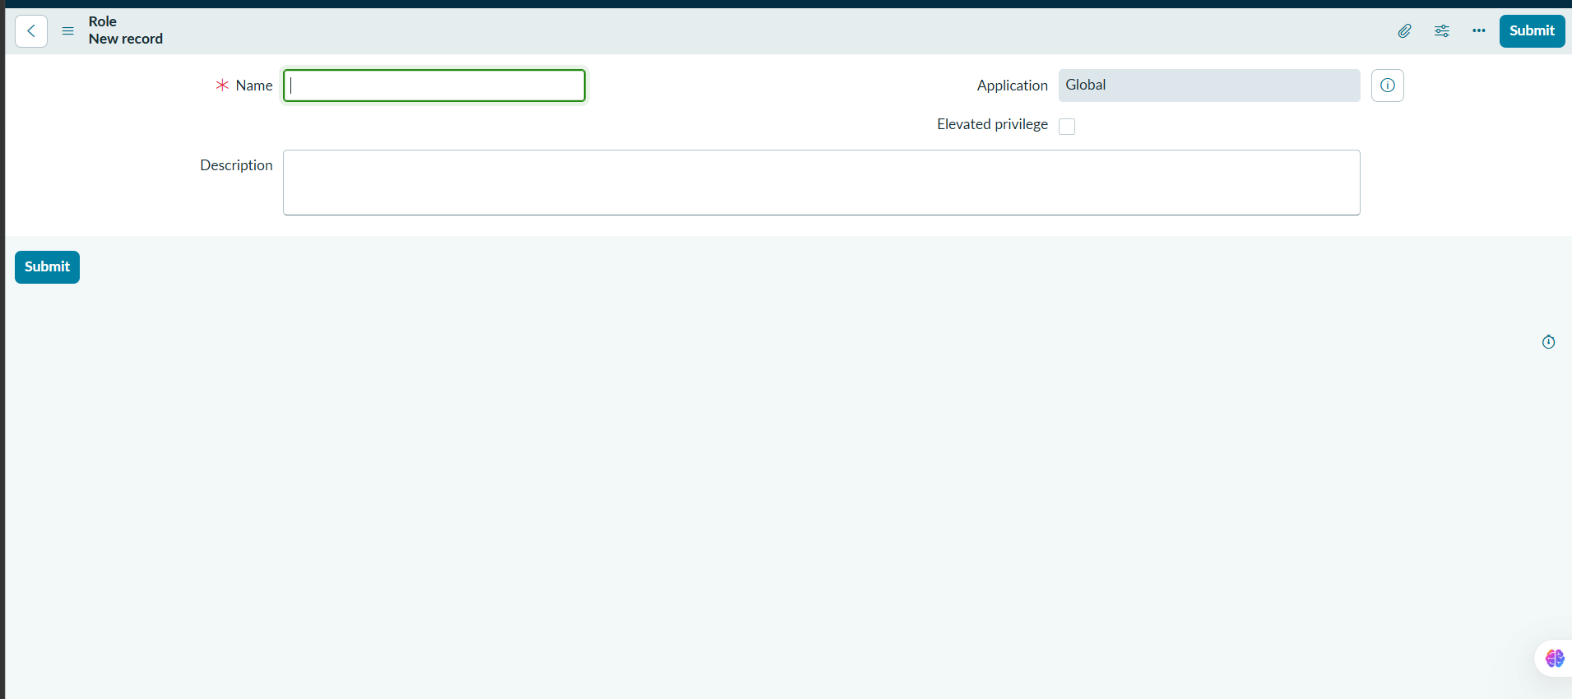

Role form with bb3 entered.
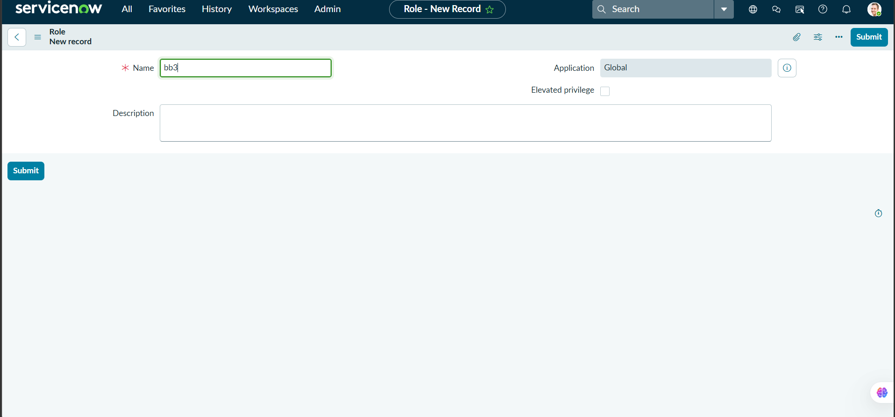

Role form with bb4 entered.
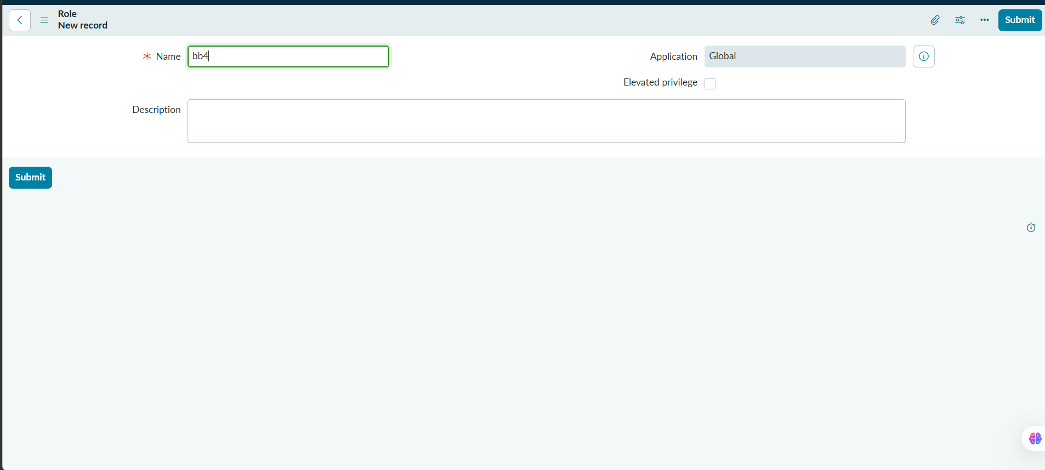

Edit Members screen shows bb1, bb2, bb3, and bb4 assigned to EEE User.
